4. Plot of Great Circles in Various Projections
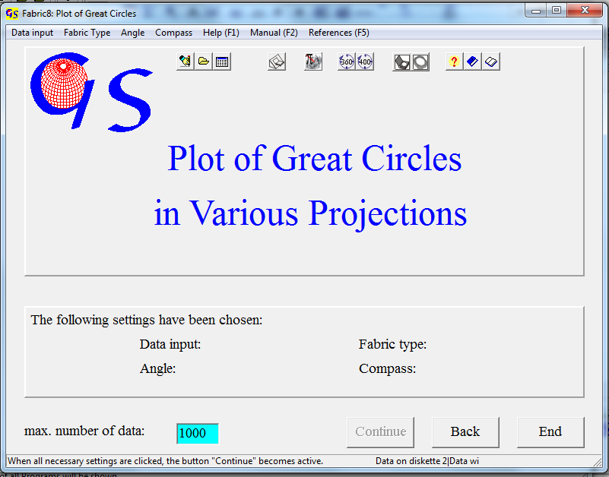
Fig.. 1

With this program (Fig. 1) planes are plotted as great circles. The used projections are the same as in program 3. The algorithm is described by WALLBRECHER (1986:39ff). Data input is the same as in program 3. Since data are planes, the extension of data files is *.PLA.
Fig. 2 shows the graphic form. Menus and settings are the same as in program 3.
The menus "Hemispere" and "Projection” are the same as in program 3.
In the menu “Plot poles” you have the option to plot the poles to the great circles (Fig. 3). In the menu “Symbol” you can choose the symbols for the poles to the planes (Fig. 4) and you can set the line style and thickness (Fig.5) of the great circles.
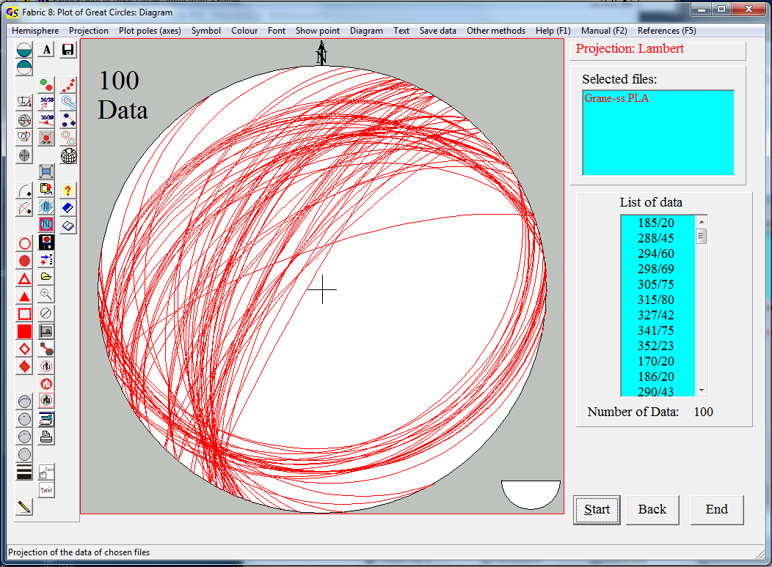
Fig. 2

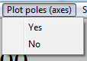
Fig. 3
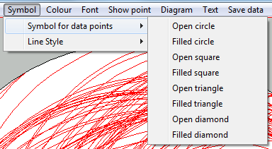
Fig. 4

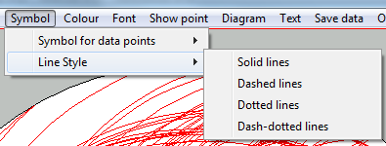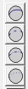
Fig. 5

For solid lines you also have to choose the width of the lines (Fig. 6).

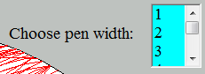
Fig. 6

The menus "Colour", "Show point", "Diagram", "Save Data" are the same as in program 3.

With “Other methods” (Fig. 7) you can jump to the programs “Plot of orientation data”, “Contoured diagrams of orientation date”, “Statistics of orientation data”, Significant separation of submaxima”, and “Projection of a sphere.

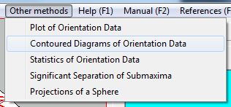
Fig. 7

